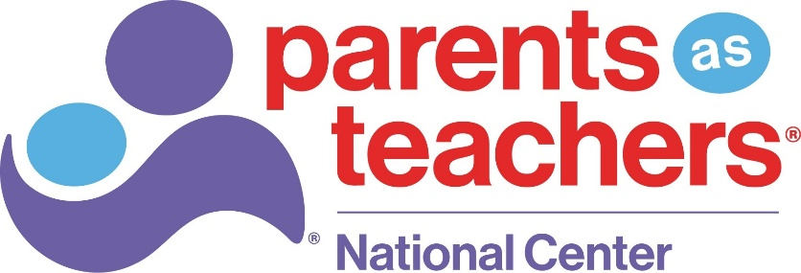
GIFT ACCEPTANCE POLICY
Parents as Teachers National Center (PATNC) solicits and accepts gifts for purposes that will help the organization further and fulfill its mission.
PATNC urges all prospective donors to seek the assistance of personal legal and financial advisors in matters relating to their gifts, including the resulting tax and estate planning consequences.
PATNC is a tax-exempt organization under section 501(c)(3) of the Internal Revenue Code and accepts charitable gifts as allowed by applicable law. It accepts online gifts (including major credit cards, ACH, Apple Pay, Google Pay, PayPal, Cash App, and DAF Pay), checks received by mail or in person during donor meetings, stock electronically transferred and payroll deductions from PATNC employees. Gifts may also be distributed through third-party giving platforms, such as PayPal Giving Fund, which processes donations made through PATNC’s Facebook page.

Reporting Policy: Gifts of cash will be reported at their face value. PATNC procedures and policies for counting, reporting and recognizing gifts comply with all IRS regulations. PATNC abides by the rules and regulations of the Financial Accounting Standards Board (FASB) as they affect the recording and receipting of gift income. PATNC will provide written acknowledgment of all charitable gifts in accordance with IRS requirements. Evaluation of noncash gifts is the responsibility of the donor.
Use of Legal Counsel— PATNC may seek the advice of legal counsel in matters relating to acceptance of gifts when appropriate. Review by counsel should be considered for:
- Gifts of securities that are subject to donor restrictions or buy-sell agreements.
- Documents naming PATNC as a trustee.
- Gifts requiring PATNC to assume financial or other obligations.
- Transactions that pose potential conflicts of interest, unreasonable degree of liability.
- Gifts of property which may be subject to environmental or other regulatory restrictions.
Restrictions on Gifts— PATNC will not accept gifts that:
- Conflict with PATNC’s mission and values.
- Would result in PATNC losing its status as an IRC 501(c)(3) not-for-profit organization.
- That require the organization to provide improper private benefit, inappropriate donor control over programs or operations, or any arrangement that could be construed as a quid pro quo beyond standard donor recognition.
- Are too difficult or too expensive to administer in relation to their value.
- Would result in any unacceptable consequences for PATNC.
- Are for purposes outside PATNC’s mission.
PATNC is committed to accepting charitable gifts that align with its mission, values, and fiduciary responsibilities. In instances where a proposed gift may present legal, ethical, financial, or reputational concerns, the gift shall be subject to a formal review process guided by this Gift Acceptance Policy.
The Chief Executive Officer and Vice President of Philanthropy shall conduct an initial assessment of any potentially controversial gift. If concerns are identified, the matter will be elevated to the Fund Development Committee of the Board of Directors for review. The Committee, led by its appointed Chair and supported by staff, will evaluate the proposed gift in accordance with this policy.
The Fund Development Committee is authorized to recommend acceptance, modification, or declination of the gift. In cases involving significant risk, ambiguity, or potential impact to PATNC’s mission or reputation, the Committee may escalate the decision to the Executive Committee and/or full Board of Directors for final determination.
All decisions will be made in good faith, with careful consideration of donor intent, organizational integrity, and the long-term best interests of PATNC.

Gifts Generally Accepted— The following gifts to PATNC are generally accepted:

Cash: Cash gifts are acceptable in any form, including by check, money order, credit card, on-line and PATNC employee payroll deduction.

Donor Advised Funds: Gifts from donor advised funds are accepted and recorded under the name of the donor advised fund sponsoring organization. Individual donors are soft credited for recognition purposes.

Marketable Securities: Marketable securities may be transferred electronically to PATNC’s stock account of record. All marketable securities will be sold promptly upon receipt unless otherwise directed by PATNC’s Finance Committee.

Bequests and Beneficiary Designations under Revocable Trusts, Life Insurance Policies, Commercial Annuities and Retirement Plans: Donors are encouraged to make bequests to PATNC under their wills, and to name PATNC as the beneficiary under trusts, life insurance policies, commercial annuities and retirement plans.

Charitable Remainder Trusts: PATNC will accept designation as a remainder beneficiary of charitable remainder trusts.

Charitable Lead Trusts: PATNC will accept designation as an income beneficiary of charitable lead trusts.
- Gifts Accepted Subject to Prior Review— Certain forms of gifts or donated properties may be subject to review prior to acceptance. Examples of gifts subject to prior review include, but are not limited to:
- Tangible Personal Property: The Fund Development Committee shall review and determine whether to accept any gifts of tangible personal property considering the following: Does the property further the organization’s mission? Is the property marketable? Are there any unacceptable restrictions imposed on the property? Are there any carrying costs for the property for which the organization may be responsible? Is the title/provenance of the property clear?
- Real Estate: All gifts of real estate are subject to review by the Finance Committee. Prior to acceptance of any gift of real estate, PATNC shall require an initial environmental review by a qualified environmental firm. If the initial review reveals a potential problem, the organization may retain a qualified environmental firm to conduct an environmental audit. Criteria for acceptance of gifts of real estate include: Is the property useful for the organization’s purposes; Is the property readily marketable? Are there covenants, conditions, restrictions, reservations, easements, encumbrances or other limitations associated with the property? Are there carrying costs (including insurance, property taxes, mortgages, notes, or the like) or maintenance expenses associated with the property? Does the environmental review or audit reflect that the property is damaged or otherwise requires remediation?
- Third-Party Fundraising Events - PATNC may accept proceeds from third-party fundraising events provided activities align with PATNC’s mission, values, and this Gift Acceptance Policy.
PATNC’s acceptance of funds from third-party events is subject to the following conditions:
- No Obligation to Promote or Manage: PATNC is not responsible for organizing, managing, staffing, or promoting third-party events. Use of PATNC’s name, logo, or materials must receive prior written approval and will be limited in scope.
- No Guaranteed Marketing Support: PATNC does not guarantee promotion of third-party events through its communication channels, including but not limited to email, social media, or website listings.
- Event Independence: Third-party events must be clearly represented as independently organized. Event organizers may not imply that the event is produced, sponsored, or endorsed by PATNC without explicit written consent.
- Minimum Financial Benefit: PATNC will only accept proceeds from events where a clear and meaningful portion of the revenue is designated as a charitable contribution. PATNC will not participate in or promote events that provide only a nominal percentage of proceeds or where the charitable component is incidental to the primary purpose of the event. Event expenses may not be deducted from proceeds prior to calculating the charitable contribution unless clearly disclosed and approved in advance.
- Compliance and Risk: Event organizers are responsible for complying with all applicable laws, securing necessary permits, insurance, and licenses, and ensuring the event does not expose PATNC to liability or reputational risk.
- Right to Decline: PATNC reserves the right to decline funds from any third-party event that does not meet these standards or that could result in conflict with PATNC’s mission, values, or public reputation.
- Donor’s Rights— PATNC is committed to ensuring the privacy and confidentiality of our donors. PATNC has adopted the Association of Fundraising Professionals Donor Bill of Rights (link: https://afpglobal.org/sites/default/files/attachments/2018-10/DonorBillofRights.pdf).

